TASK 2 : BASIC HUMAN RESOURCE (HR) POLICY

Startup Company
Document Type: Human Resource Policy
Effective Date: 03 November 2026
Applicable To: All Employees

1. Introduction
The purpose of this HR policy is to establish clear workplace guidelines and expectations for all employees of the organization. It aims to create a professional, respectful, productive, and flexible working environment.
This policy applies to all full-time, part-time, temporary, and remote employees of the startup.

2. Leave Policy
The company understands the importance of employee well-being and work-life balance. Employees are provided with leave benefits according to company rules and applicable labour laws.
2.1 Types of Leave
- Casual Leave: Employees are entitled to 12 days of casual leave per year for personal reasons or unexpected situations.
- Sick Leave: Employees are entitled to 12 days of sick leave per year in case of illness or medical emergencies. A medical certificate may be requested for extended absence.
- Earned Leave: Employees are entitled to 15 days of earned leave per year, subject to company rules and applicable laws.
- Maternity Leave: Eligible employees will receive maternity benefits according to applicable Indian labour laws.
- Unpaid Leave: Employees may request additional leave without pay with prior approval from their reporting manager.
2.2 Leave Application Procedure
- Employees should apply for planned leave in advance through the company's leave management system or HR department.
- Emergency leave should be communicated to the reporting manager as early as possible.
- Leave approval depends on business requirements and available leave balance.
- Employees should inform their manager about their expected date of return.

3. Code of Conduct
The company expects all employees to maintain professional behaviour and follow ethical workplace practices.
3.1 Professional Behaviour
- Employees must treat colleagues, managers, clients, and customers with respect.
- Discrimination, harassment, bullying, and inappropriate behaviour are strictly prohibited.
- Employees should maintain punctuality and complete assigned responsibilities on time.
3.2 Workplace Ethics
- Employees must be honest, responsible, and transparent in their work.
- Company resources should be used appropriately and responsibly.
- Employees must avoid conflicts of interest and report unethical activities to HR or management.
3.3 Confidentiality and Data Protection
- Employees must protect confidential company information and customer data.
- Sharing internal documents, passwords, or sensitive information with unauthorized individuals is prohibited.
- Company information should only be accessed for authorized work purposes.
3.4 Dress Code and Communication
- Employees should maintain a neat and professional appearance.
- Communication with colleagues should remain polite and respectful.
- Employees should follow company guidelines when using official email, messaging platforms, and social media.
3.5 Disciplinary Action
Violations of company policies may result in verbal warnings, written warnings, suspension, or further disciplinary action depending on the seriousness of the violation and applicable laws.

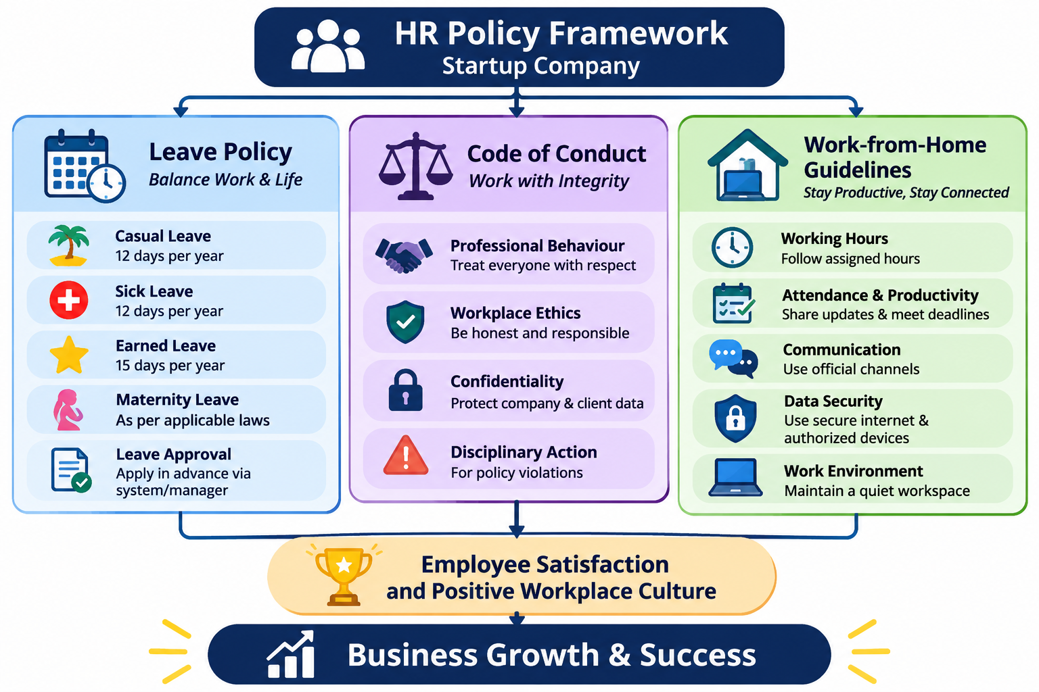

4. Work-from-Home (WFH) Guidelines
The company supports flexible working arrangements to improve employee productivity and work-life balance. Employees may be allowed to work remotely based on their job responsibilities and management approval.
4.1 Working Hours
- Employees must follow their assigned working hours.
- Employees should be available during agreed working hours.
- Any changes to working schedules must be communicated to the reporting manager.
4.2 Attendance and Productivity
- Employees must mark their attendance through the approved system.
- Daily tasks and project updates should be shared with the reporting manager.
- Employees are expected to attend scheduled virtual meetings.
- All assigned tasks must be completed within the agreed deadlines.
4.3 Communication Guidelines
- Employees should remain reachable through official communication channels.
- Email, video conferencing, and messaging applications should be used for work-related communication.
- Employees should inform their manager if they face internet or technical issues that affect their work.
4.4 Data Security
- Employees must use secure internet connections and authorized devices.
- Company files and confidential information must not be shared with unauthorized individuals.
- Employees should use approved software and follow cybersecurity guidelines.
- Devices should be protected with strong passwords and security updates.
4.5 Work Environment
- Employees should maintain a quiet and comfortable workspace.
- Employees should take appropriate breaks during working hours.
- Professional behaviour must be maintained during online meetings.

5. Policy Review and Approval
This HR policy will be reviewed periodically by the HR department and management to ensure that it remains relevant to the company's requirements and applicable employment laws.
The company reserves the right to update or modify these policies when necessary, with appropriate communication to employees.
Approved By: HR Department / Management
Conclusion:
This basic HR policy helps establish a positive workplace culture by ensuring fair leave practices, professional employee behaviour, and effective remote working arrangements. It supports employee satisfaction, organizational discipline, and overall business growth.

